**IPE 1051 : CPI Term End Assignment**

***Title:* Strategies of CPI in Practice**

***Objective:***

**• To connect the theory to practice and to learn the relevance**

**• To consolidate the learning and to broaden the purview of the concepts studied**

**in the class.**

**• To promote skills for self-study and reference to literature.**

**• To develop the documentation, teamwork, and interpersonal skills**

**B) Problem Concerned to Society-**

**Unemployment**

**Various practices of solving problem. (The CPI strategy employed / matching**)

1. **Find the questions**
2. **Search the space**
3. **Transform the problem**

**Importance of asking question:**

Asking the right question is the most important thing. Questioning the society can lead to solution to the problems and revolutions.

**The First Practice of Asking: Find the Question**

**What is Unemployment? First.**

The term unemployment refers to a situation when a person who is actively [searching for employment](https://www.investopedia.com/financial-edge/0711/9-different-ways-to-find-a-new-job.aspx) is unable to find work.

**Why Unemployment happens?**

Unemployment is caused by various reasons that come from both the demand side, or employer, and the supply side, or the worker.

Demand-side reductions may be caused by high interest rates, global recession, and financial crisis. From the supply side, frictional unemployment and structural employment play a great role.

**What is Frictional & Structural unemployment?**

Frictional unemployment refers to those workers who are in between jobs. An example is a worker who recently quit or was fired and is looking for a job in an economy that is not experiencing a recession

[Structural unemployment](https://corporatefinanceinstitute.com/resources/knowledge/economics/structural-unemployment/) happens when the skills set of a worker does not match the skills demanded by the jobs available, or alternatively when workers are available but are unable to reach the geographical location of the jobs.

Creativity starts with a penetrating research question, mastering the discipline of asking means you're always looking for good problems, always seeking new inspiration. You know where you're going, and yet you're receptive to questions that emerge unexpectedly.

**The Second Practice of Asking: Search the space**

* **Break it down**
* **Fishbone diagram**
* **Mind mapping**

**What causes Unemployment and what are its consequences?**

The impact of unemployment can be felt by both the workers and the national economy and can cause a ripple effect.

Unemployment causes workers to suffer financial hardship that impacts families, relationships, and communities. When it happens, consumer spending, which is one of an economy’s key drivers of growth, goes down, leading to a recession or even a depression when left unaddressed.

Unemployment results in reduced demand, consumption, and buying power, which in turn causes lower profits for businesses and leads to budget cuts and workforce reductions. It creates a cycle that goes on and on that is difficult to reverse without some type of intervention.

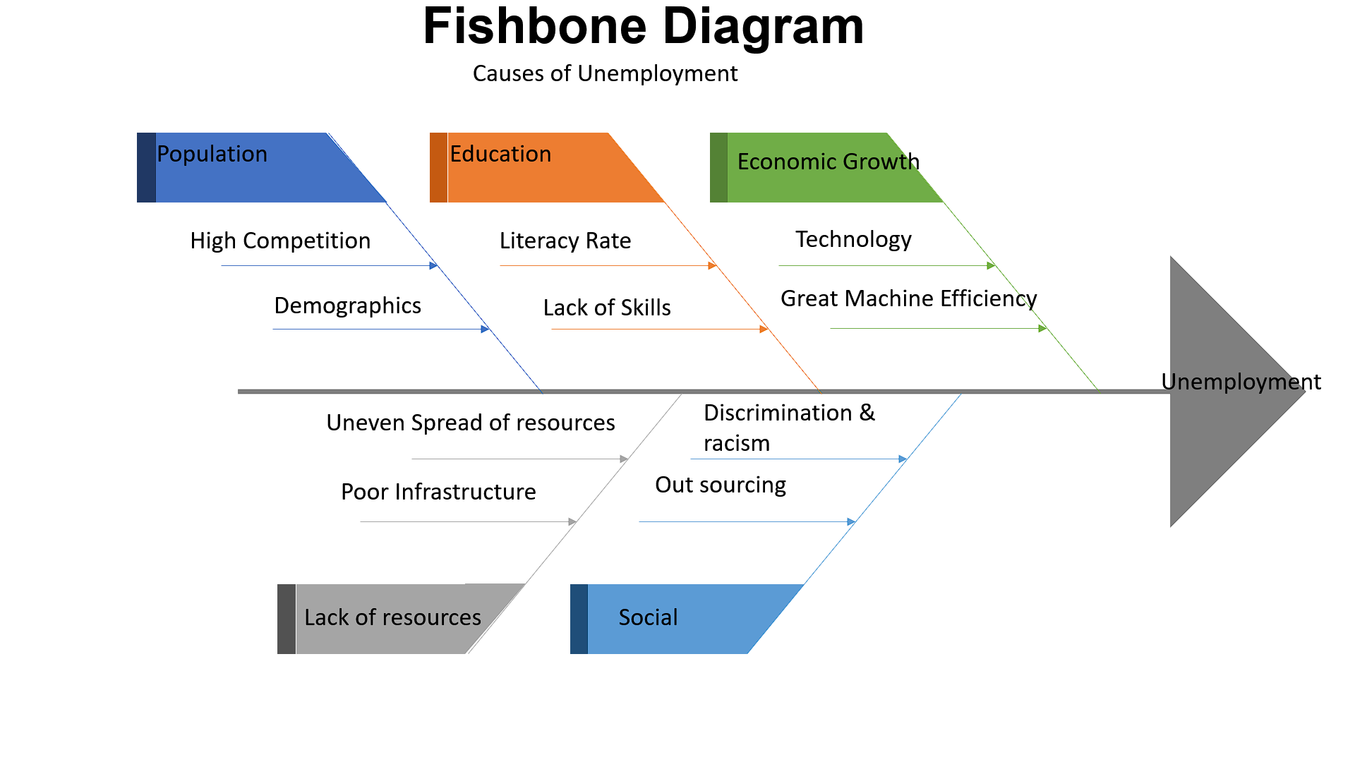

**The Third Practice of Asking: Transform the problem**

The first two practices, Find the Question and Search the Space, help you generate long lists of problem statements. The third practice dares you to think about your challenge in a completely different way. The techniques are intended to shock you out of your assumptions.

* **Reverse**
* **Go back from the Future**
* **Stretch and squeeze**

**SOLUTIONS-Transform the Problem to Solution.**

**(i)Change in industrial technique:**

Production technique should suit the needs and means of the country. It is essential that labour intensive technology should be encouraged in place of capital-intensive technology.

**(iii) Population control:**

The growth of population should be checked to solve unemployment, problem. Family planning programme should be implemented widely and effectively.

**(ii) Policy regarding seasonal unemployment:**

Seasonal unemployment is found in agriculture sector and agro based industries.

**To remove it:**

(a) Agriculture should have multiple cropping,

(b) Plantations, horticulture, dairying, and animal husbandry should be encouraged,

(c) Cottage industries should be encouraged.

**(iv) Expansion of Employment exchanges:**

More employment exchanges should be opened. Information regarding employment opportunities should be given to people.

**(v) More assistance to self-employed people:**

Most people in India are self-employed. They are engaged in agriculture, trade, cottage and small-scale industries etc. These persons should be helped financially, providing raw materials and technical training.

**(vi) Full and more productive employment:**

The main objective of county’s employment policy should be to increase employment opportunities and productivity of labour. Govt. should adopt a policy that provides employment to all people.

**(vii) Increase in Production:**

To increase employment, it is essential to increase production in agriculture and industrial sectors. Development of small and cottage industries should be encouraged.

**(viii) More importance to employment programmes:**

In five year plans more importance should be given to employment. The programmes like irrigation, roads, flood control, power, agriculture, rural electrification can provide better employment to people.

**(ix) High rate of capital formation:**

Rate of capital formation in the country should be accelerated. Capital formation should be particularly encouraged in such activities which generate greater employment opportunities. Capital output ratio should be kept low.

**(x) Industries in co-operative sector:**

Industries in co-operative sector should be encouraged. Kerala Govt.’ set up a textile mill covering 600 unemployed persons on co-operative basis. This is a novel approach to fight against unemployment. Different State Govt. should take necessary steps in this direction.

**(xi) Decentralisation of industrial activity:**

Decentralisation of Industrial activity is necessary to reduce unemployment. If industrial activities are centralised at one place, there will be less employment opportunities in the underdeveloped areas. So, Govt. should adopt such policies which encourage decentralisation of industrial activity.

**(xii) Change in education system:**

Educational pattern should be completely changed. Students who have liking for higher studies should be admitted in colleges and universities. Emphasis should be given on vocational education. Qualified engineers should start their own small units.

**Conclusion-**

Unemployment is a serious and an important challenge which needs to be looked and removed from the country. As we know, in country like India, Unemployment is one of the biggest challenges. Government should implement job opportunities for the young youth who are willing to work.  
Plus, there should be more job opportunities in the rural areas too and a system of giving opportunity of interview. Courses should be arranged for the youth to motivate even if they aren't employed.  Individuals must take initiative steps in increasing the productivity and improving the standard of living.

**Reference-**https://www.economicsdiscussion.net/  
https://corporatefinanceinstitute.com/

https://www.investopedia.com/

https://www.economicshelp.org/

**Details of Team members with their register numbers.**

**Made by GROUP 36**

Daksh Dadhania – 210911072

Sneagen Jai B - 210907302

Vaibhav Narang - 121002039

Ishaan Agarwal – 210905184